AWS ADVANCE -LU PROJECT 7:
Project Name: Project-DevOps-Jenkins-Installation and Configuration on Linux
https://pkg.jenkins.io/redhat-stable/
Install java
Screenshot for installing java;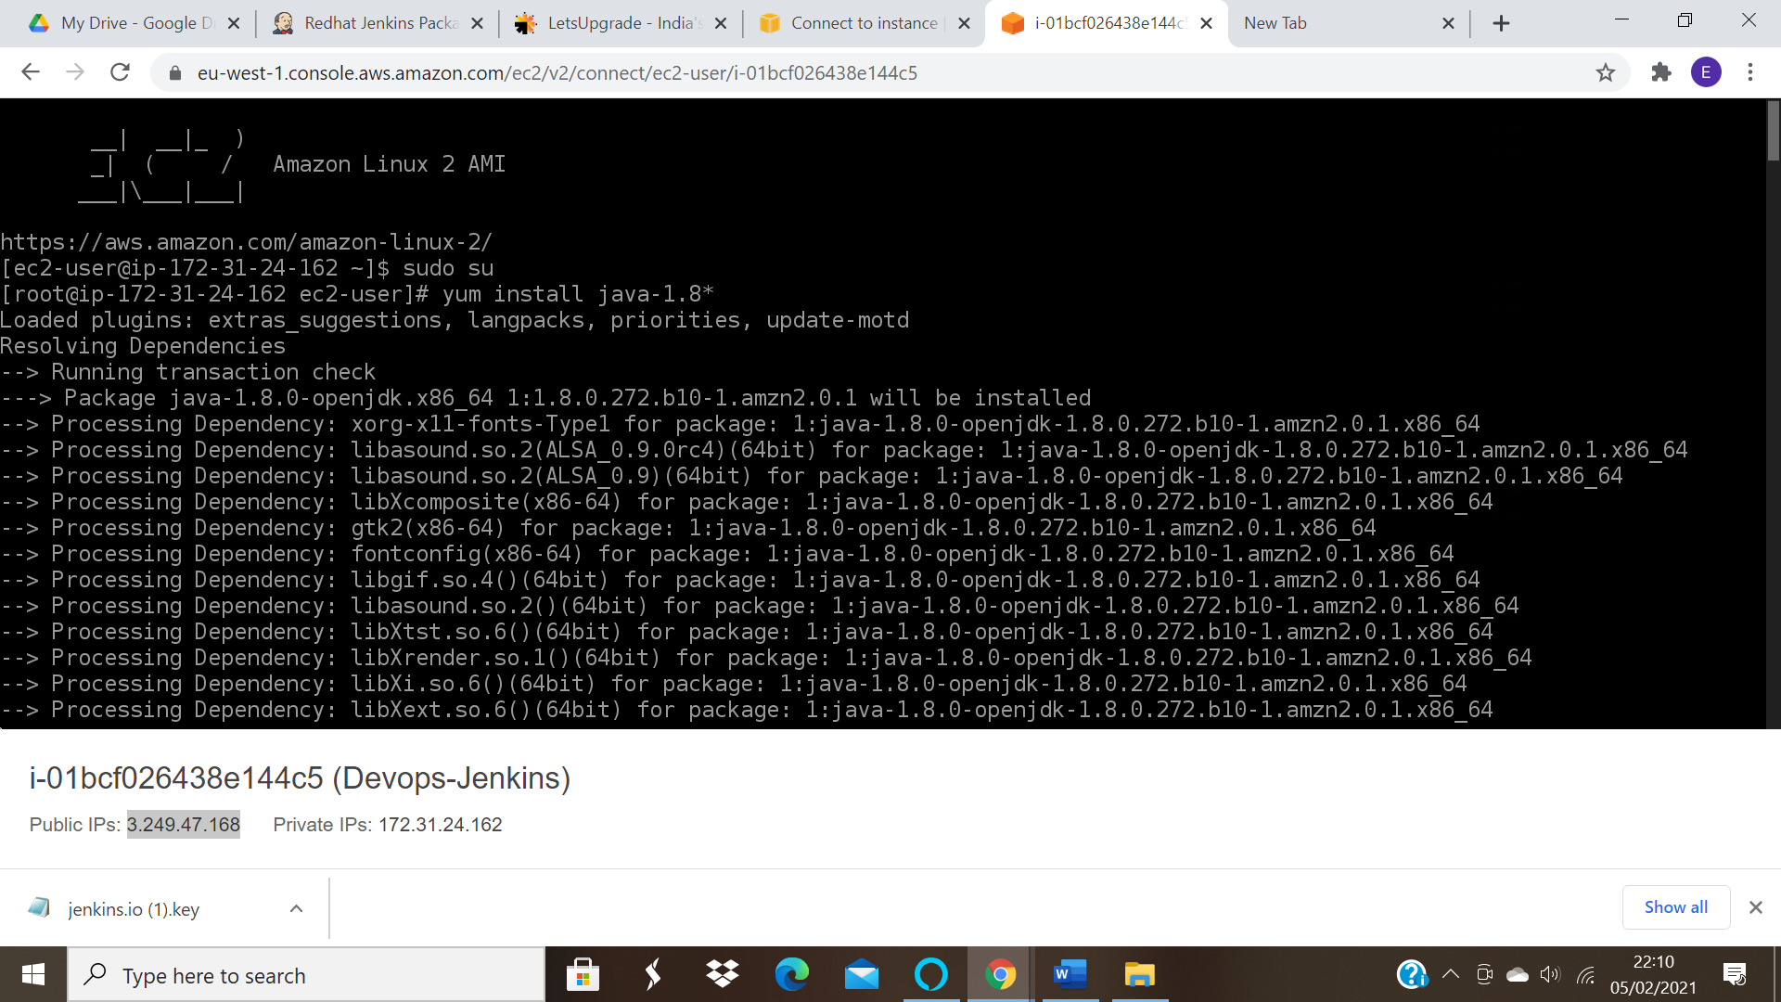

sudo wget -O /etc/yum.repos.d/jenkins.repo https://pkg.jenkins.io/redhat-stable/jenkins.repo
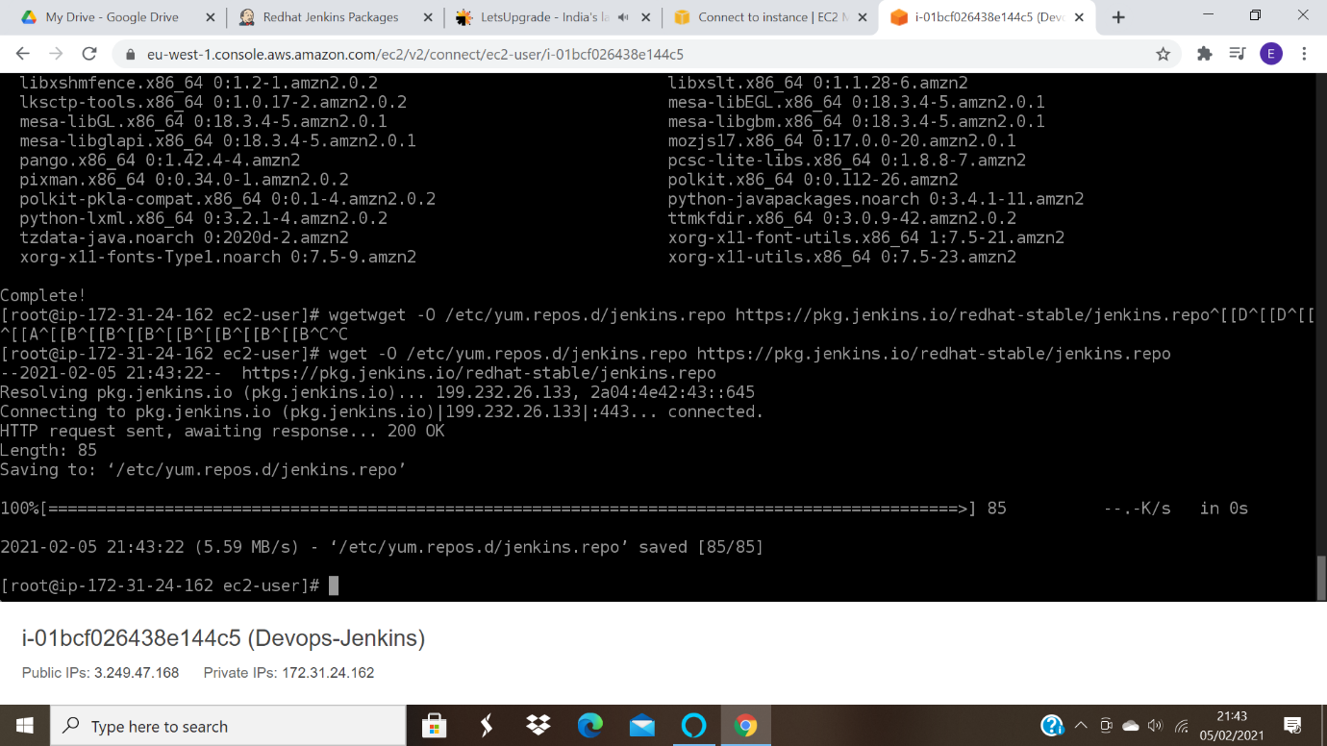

sudo rpm --import https://pkg.jenkins.io/redhat-stable/jenkins.io.key
Screenshot for importing rpm:
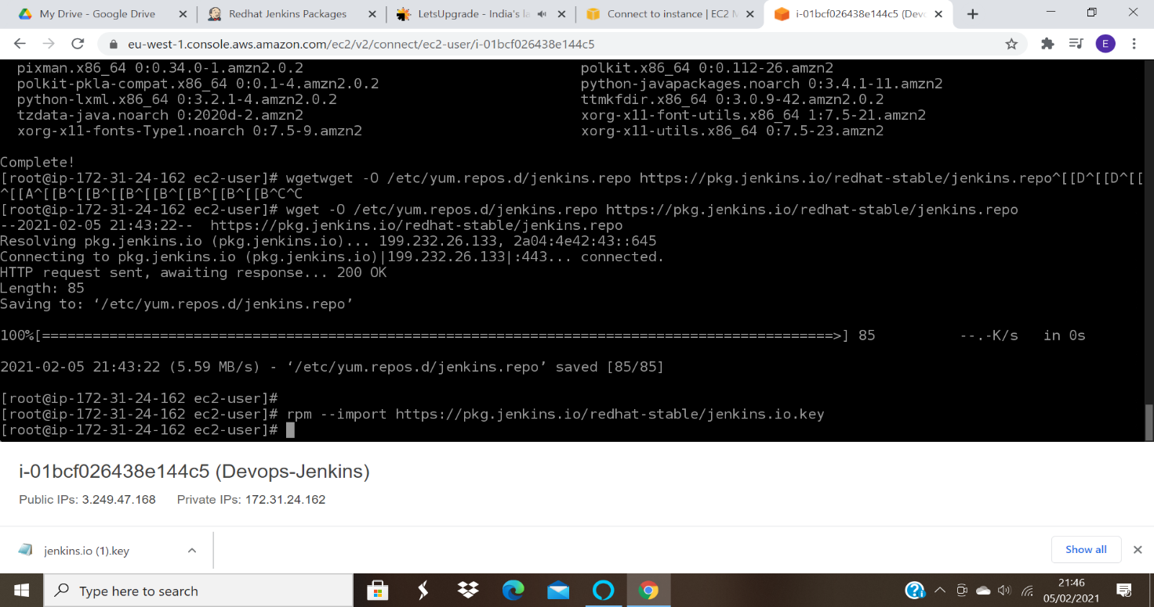
yum install Jenkins

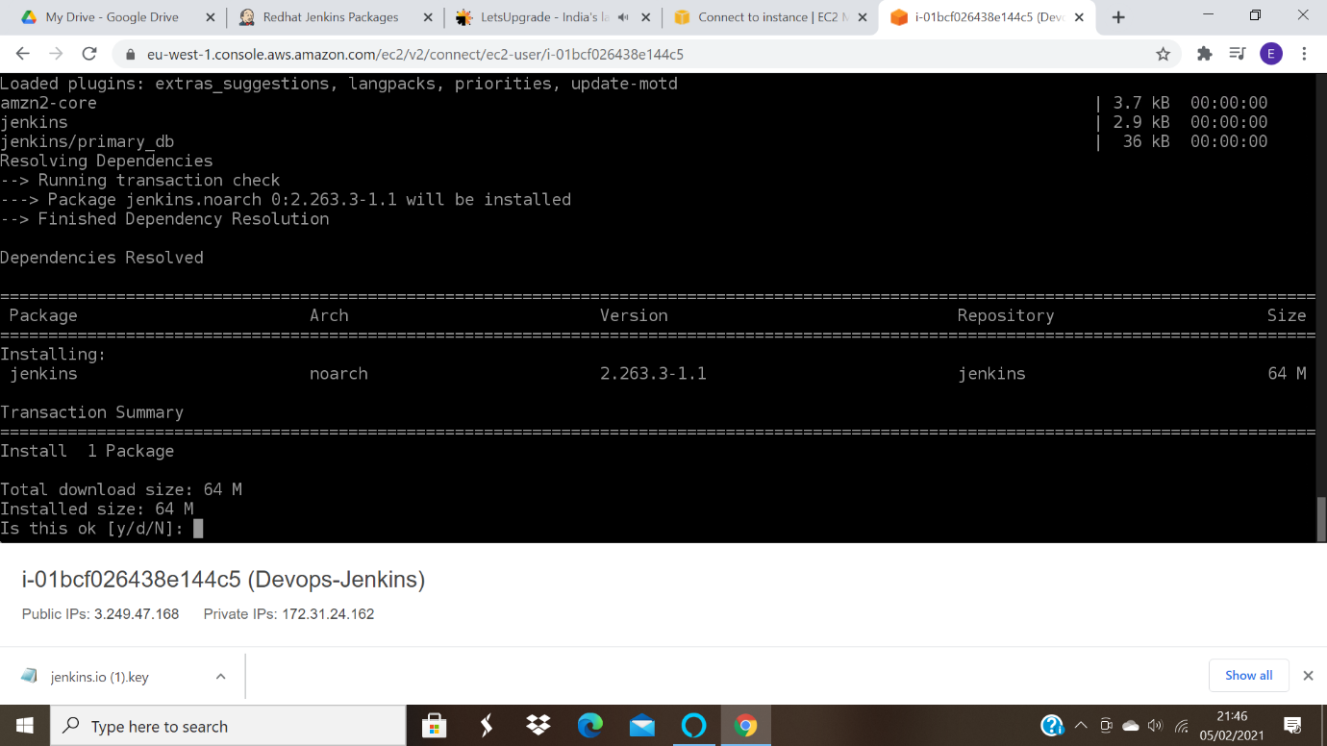
extract the password from the location
Screenshot for extracting the password
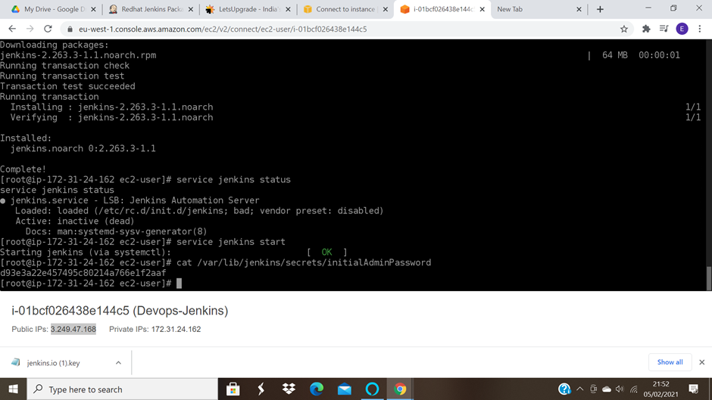
skip installing plugins
Start using jenkins
Change the admin password
Create a new job
Build step: execte shell
echo "hello"
Screenshot for the executed shell:
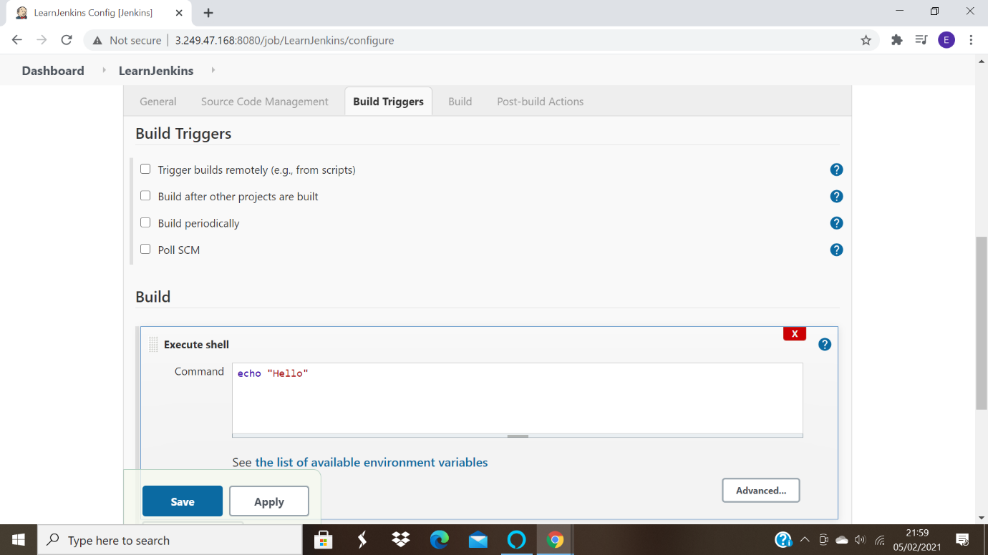

build the job
Screenshot for the successful build:
